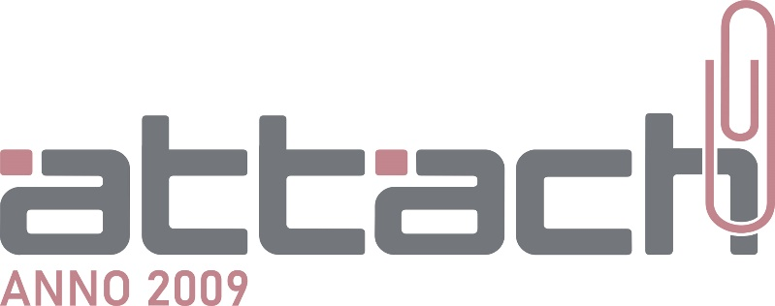

Nosaukums: SIA Attach
Reģistrācijas nr.: 40103266248
PVN nr.: LV40103266248
Adrese: A. Deglava iela 28-5, Rīga, LV-1009
Banka: AS Swedbank
Konta nr.: LV78HABA0551027263955
SWIFT: HABALV22

Company: Attach Ltd.
Reg.No.: 40103266248
VAT code: LV 40103266248
Address: Deglava street 28-5, Riga, LV-1009, Latvia
Bank: AS Swedbank
Account number:LV78HABA0551027263955
SWIFT: HABALV22

